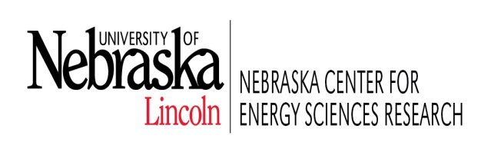 | Materials for Energy Systems Symposium  July 21, 2015

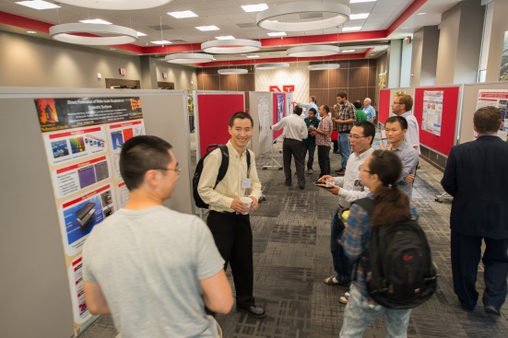 | 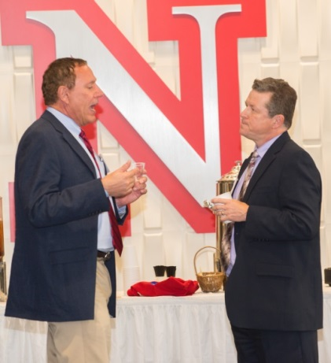 | 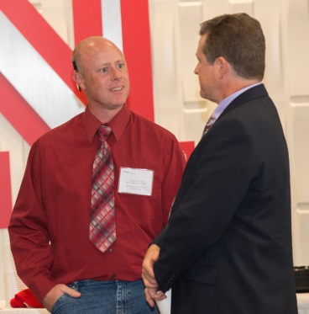
The symposium encouraged sharing ideas between colleagues and departments | Michael Nastasi (NCESR) and Stephen Ducharme (Physics) sharing ideas. | George Peterson (MME) Graduate Student) visiting with Dr. Ducharme
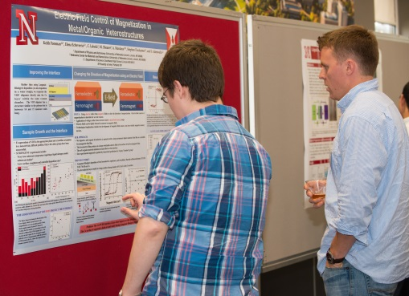 | 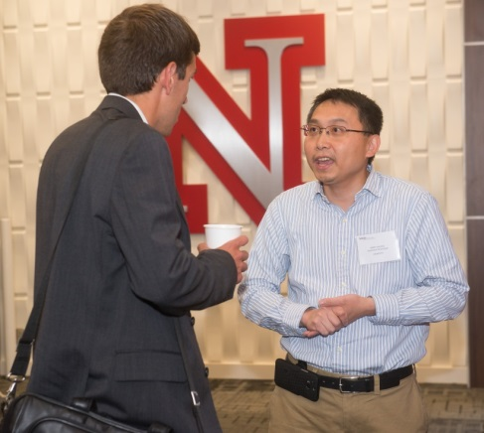 | 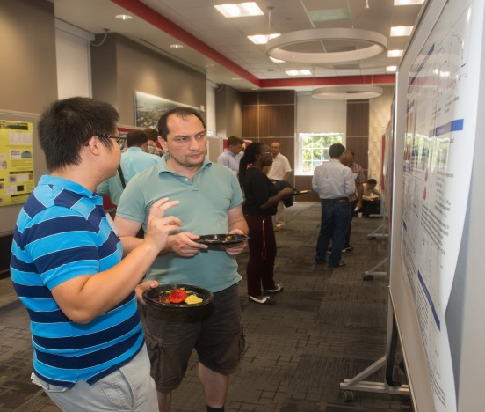
Keith Foreman and Mike Street (Physics) studying their research | Dr. Alexander Sinitski and Dr. Barry Cheung (Chemistry) have a lively research discussion | Junlei Wang (Physics) explains his research to an interested party
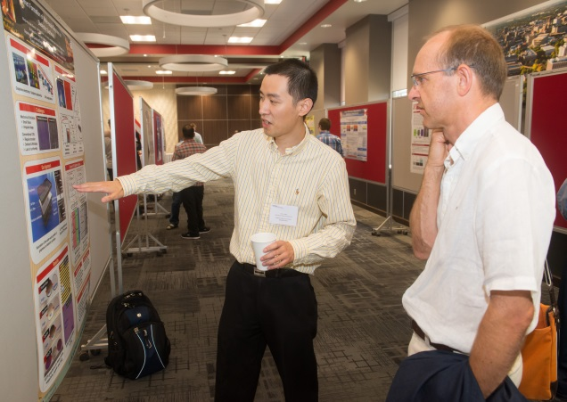 | 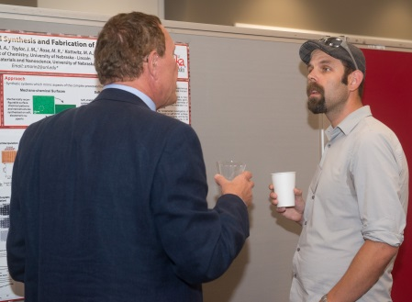 | 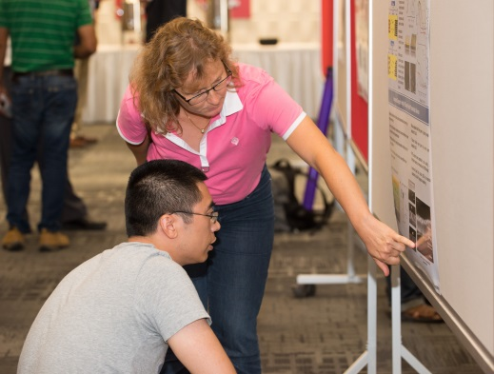
Wei Xiong (ECE) explaining his research to Dr. Peter Sutter (ECE) | Michael Nastasi discussing Dr. Stephen Morin’s (chemistry) research | Dr. Eva Schubert (ECE) explaining her research to a very interested symposium participant.
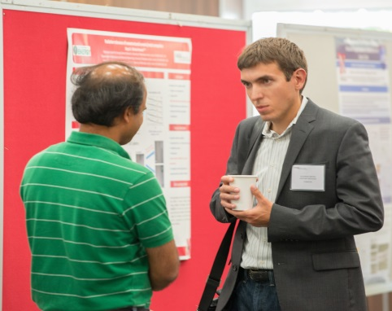 | 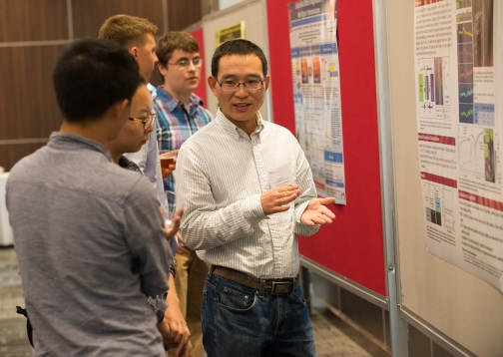 | 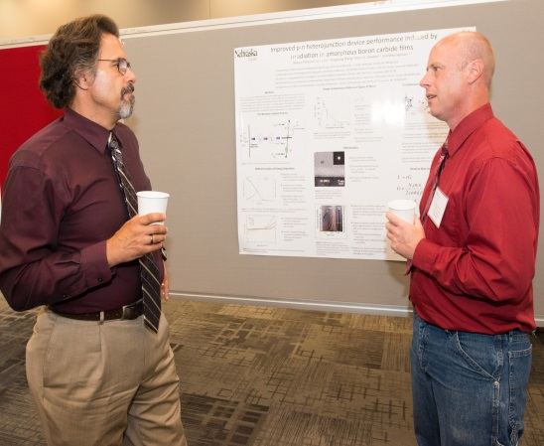
Dr. Sinitski (Chemistry) discussing research project. | Shumin Li (MME) explaining poster | Dr. Ianno (ECE) visiting with George Peterson (MME) about his poster
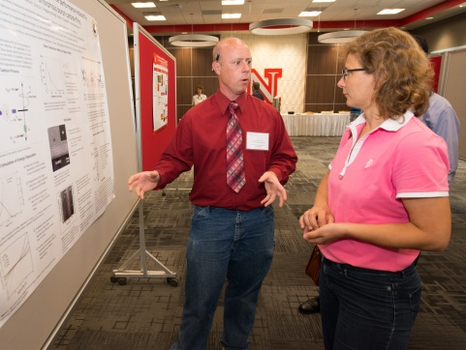 | 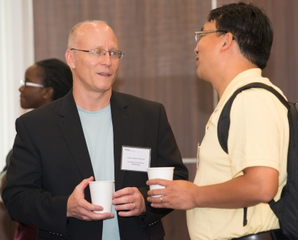 | 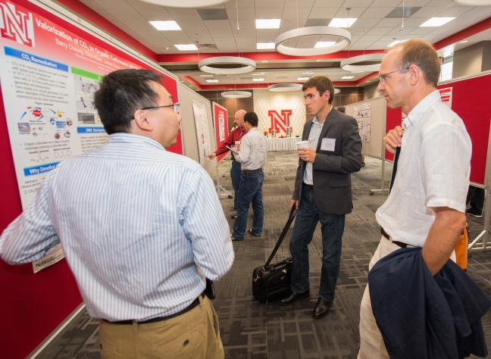
George Peterson (MME) explaining his research to Eva Schubert (ECE) | Dr. Joseph Turner (MME) discussing science with Jian Wang (MME) | Dr. Barry Cheung (Chemistry) describing his research to fellow scientists.
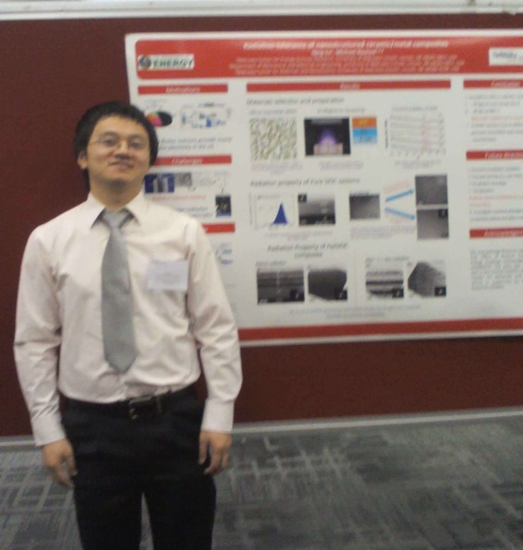 | 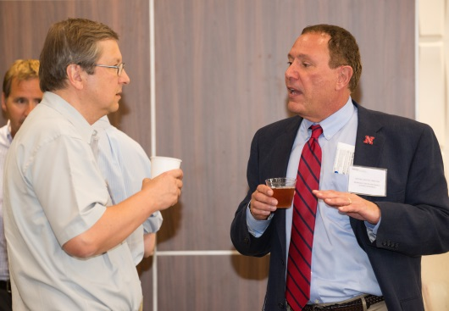
Dr. Qing Su (MME) with poster | Dr. Evgeny Tsymbal (Physics) and Michael Nastasi (NCESR)
The Materials Symposium was held to encourage faculty from within the University of Nebraska to share their research and to foster ideas in the materials for energy systems area. The majority of participants were from the following departments: Chemistry, Electrical and Computer Engineering (ECE), Mechanical and Materials Engineering (MME), and Physics and Astronomy. The event was hosted by the Nebraska Center for Energy Sciences Research (NCESR).

